|  |  |
| --- | --- |
| **WC Logo.emf** | **Staff Report to the Weber County Commission**  *Weber County Planning Division* |
|  | |

****Synopsis****

****Application Information****

**Application Request:** A public hearing to consider and take action on a request to vacate by ordinance the side public utility easements within lots 119, 120, 121, and 122 of the Evergreen Park Subdivision No. 1.

**Agenda Date: Tuesday, July 19, 2022**

**Applicant:** Emily Nicolosi, Owner

**File Number:** VAC 2022-02

****Property Information****

**Approximate Address:** 2223 North Fork Road, Huntsville, UT

**Project Area:** 17.89 acres

**Zoning:** F-40 Zone

**Existing Land Use:** Forest/Residential

**Parcel ID:** 23-026-0033, 23-026-0034, 23-026-0035, 23-026-0036

**Township, Range, Section:** T7N, R3E, Section 31

****Adjacent Land Use****

**North:** Forest **South:** Forest

**East:** Forest **West:** Forest

****Staff Information****

**Report Presenter: Felix Lleverino**

flleverino@co.weber.ut.us

**801-399-8767**

**Report Reviewer:** SB

Background and Summary

The applicant is requesting to vacate the side public utility easement within lots 119, 120, 121, and 122.

Questar Gas provided written acceptance letters of the petition. A Notice of Public Hearing was sent to the Rocky Mountain Power Operations Manager, Mr. Karl Sewell.

A vacation ordinance, seen in Exhibit B, is the chosen instrument to execute the vacation. Weber County Engineering has provided written consent to the public utility easement vacation request. The Weber County Attorney has reviewed the ordinance and approved it.

Summary of County Commission Considerations

The County Commission will need to determine if there will be any detrimental impacts caused by vacating the proposed public utility easements. Utah Code §17-27a-609.5 states that *“The legislative body may adopt an ordinance granting a petition to vacate some or all of a public street, right-of-way, or easement if the legislative body finds that:*

*(a) good cause exists for the vacation; and*

*(b) the public interest or any person will not be materially injured by the proposed vacation.*

Conformance to the General Plan

Vacating the identified easement will not contradict the Ogden Valley General Plan.

Staff Recommendation

Staff recommends approval of the request to vacate the side public utility easement within lots 119, 120, 121, and 122. This recommendation for approval is subject to all review agency requirements.

The recommendation is based on the following findings:

1. Vacating the proposed public utility easement is not contrary to the Ogden Valley General Plan.
2. Good cause exists to vacate the public utility easements
3. The public interest or any person will not be materially injured by the proposed vacation.

Exhibits

1. Easement Vacation Application with Narrative
2. Vacation Ordinance

Location Map

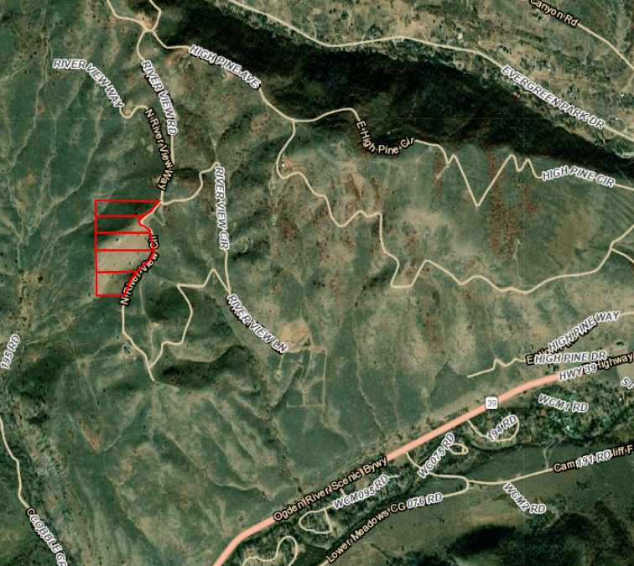

Exhibit A

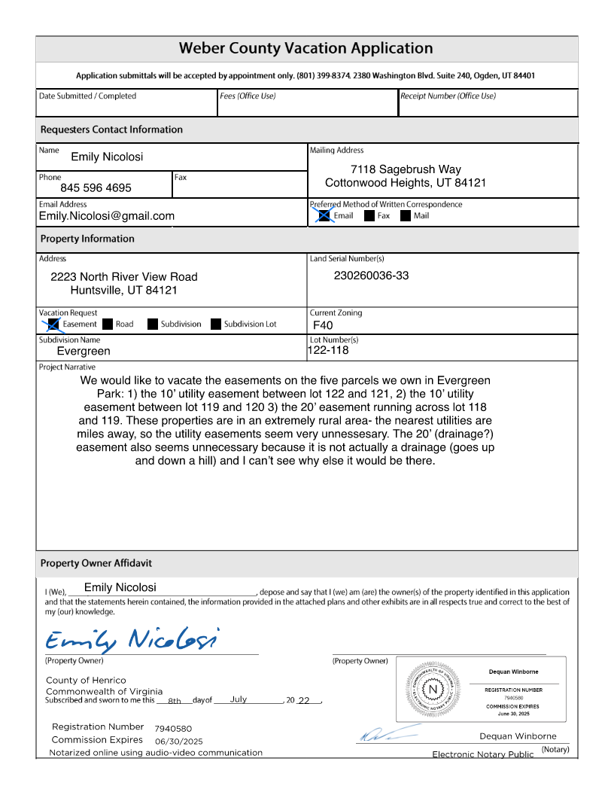

**Ordinance No.**

**An ordinance of Weber County vacating the side Public utility easements within lots 119, 120, 121, 122, of the evergreen park subdivision no. 1**

**WHEREAS,** the owner has filed a petition to vacate the side public utility easements within lots 119, 120, 121, 122, of the Evergreen Park Subdivision No. 1, as depicted in Exhibit A of this ordinance; and

**WHEREAS,** after providing proper public notice, a public hearing was held before the Weber County Commission on July 19, 2022, regarding the vacation of the public utility easements; and

**WHEREAS,** Weber County’s Engineering Department has been notified and has provided written approval of the public utility easement vacation; and

**WHEREAS,** the Commission finds that good cause exists to vacate the public utility easement, and that it will not substantially affect the Ogden Valley General Plan, and that neither the public interest nor any person will be materially injured;

**NOW THEREFORE,** the Board of County Commissioners of Weber County ordains as follows: the side public utility easements within lots 119, 120, 121, 122, of the Evergreen Park Subdivision No. 1 are hereby vacated, as depicted in Exhibit A of this ordinance.

This Ordinance shall be effective 15 days after publication in the Standard Examiner.

Adopted and ordered published this 19th day of July 2022.

Weber County Commission

By_________________________________

Scott Jenkins, Chair

Commissioner Jenkins Voted

Commissioner Harvey Voted

Commissioner Froerer Voted

ATTEST:

_________________________________

Ricky Hatch, CPA

Weber County Clerk

Exhibit A

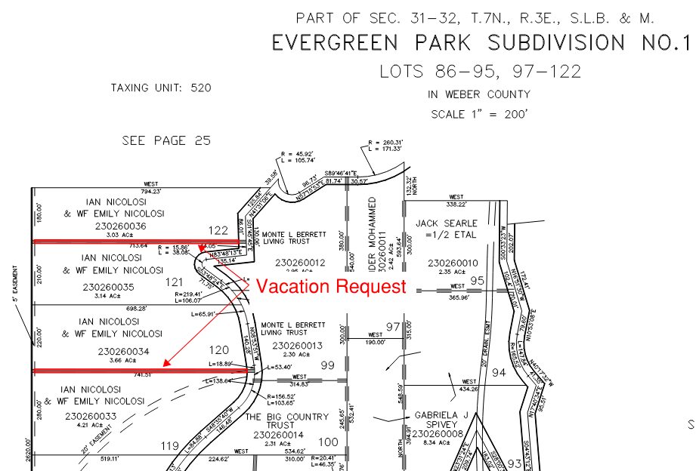

Recorder’s plat 23-026